Attachment B – Site Map
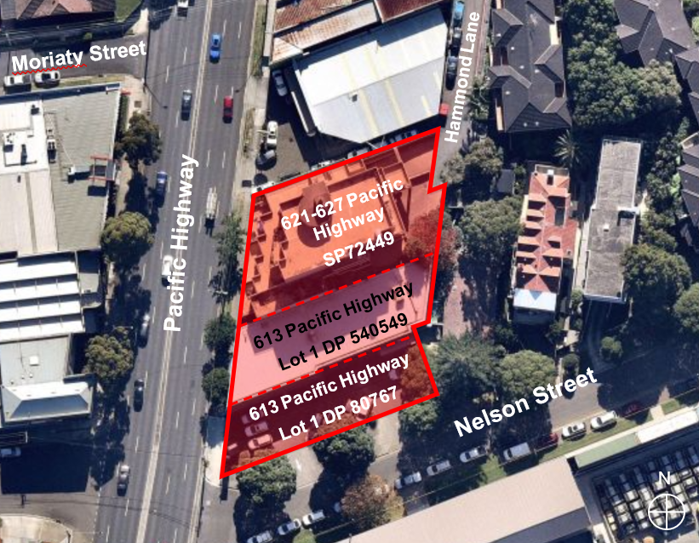
Figure 1: Site map (source: Nearmap, overlay by DPIE)

